Shiell Park
649 C St Fillmore, CA
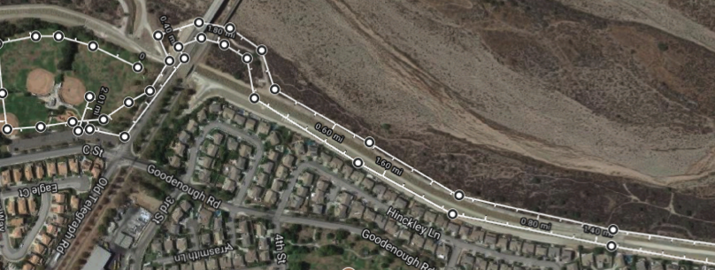
***Course begins in upper left corner of grass as seen from above, follows the tree line around the edge of the grass like a track, and exits at the side gate on the upper center section of the grass. Runners make a LEFT and follow the bike path to the right under the street and to the turn-around point at top of map. Runners return to the park via the same bike path, but enter through the front entrance and run straight to the baseball field straight ahead for the finish. Please advise runners of uneven ground and trees on grass portions of the course. Please also advise them not to cut the course, course monitors will be watching and writing down numbers.
***Parking is limited. There is a small lot at the park, and cars may also park in the surrounding neighborhoods, or in the parking lot of Fillmore Middle School, and walk over.

