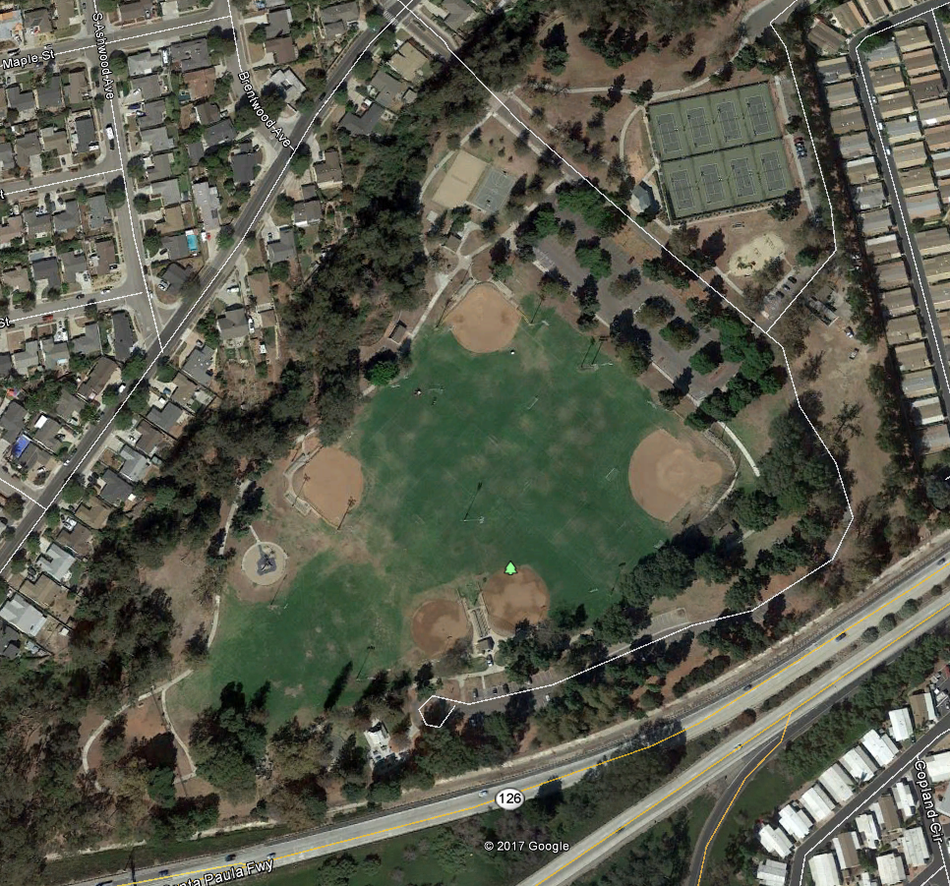

0.5mim

2017 Camino Real

Elementary School

Course Map

One mile (1615 meters)

Red Dash – First Loop

Purple Dash – Second Loop

Finish

Start