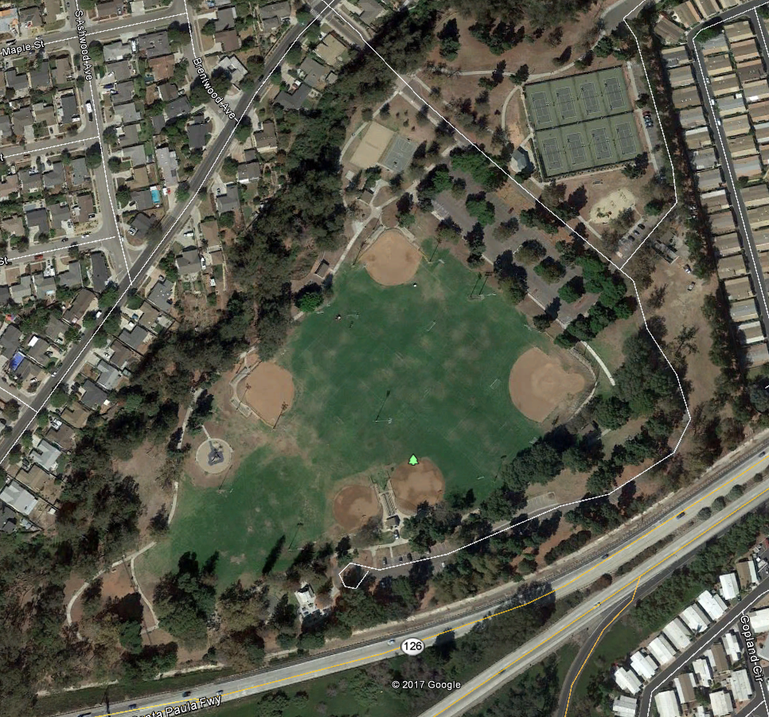

2k

1k

2017 Camino Real

Middle School

Course Map

3k (exactly 3000m)

Blue Dash – First Loop

Purple Dash – Second Loop

Orange Dash – Third Part

Finish

Start